**4 P’s Marketing Mix Template**



**This template addresses how to use one of the oldest marketing concepts in today's world:**

**"The Marketing Mix," which is based on the 4 P's:**

**Product**

**Price**

**Place**

**Promotion**

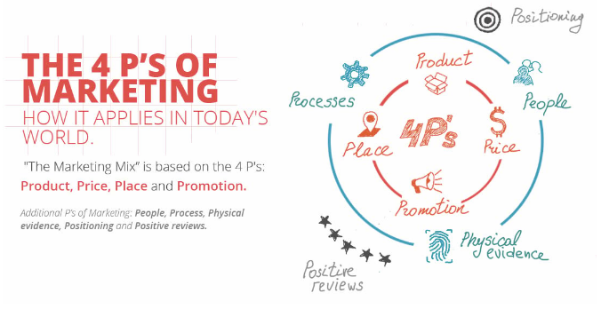



|  |  |  |
| --- | --- | --- |
| **PRODUCT** | | |
| **Question** | **Example** | **Your Answer** |
| ***Who is your target customer?*** | * homeowner * 29-59 years old * lives in London * 60K+ annual income * have children | * **edzeni kivanoknak** * **16-60 eves** |
| ***What does the customer expect from your products and services?*** | * quick response * high quality * great customer service * prestige * status | * **magas minoseg** * **presztizs** * **jo ugyfelszolgalat** |
| ***Describe benefits*** | * best warranty * saves money * more secure * local | * **garancia** * **biztonsag** |
| ***Describe features (for product)*** | * unique design * higher quality * faster * smaller * made of metal * multiple colors | * **egyedi dizajn** * **modularis** * **okos** * **akadalymentesitett** |
| ***Describe how is it different from competition*** | * more experienced * high quality materials * better reputation | * **modernebb** * **magas minosegu anyagok** |
| ***How is your product/service branded?*** | * unique memorable branding that is consistent throughout all the physical and online channels | * **emlekezetes reklam** |

|  |  |  |
| --- | --- | --- |
| **PRICE** | | |
| **Question** | **Example** | **Your Answer** |
| ***What is the value of your product/service to the customer?*** | * solves problems quickly and affordably unique and scarce * knowledge and expertise | * **kis befektetesbol hatalmas eredmenyt lehet szerezni** |
| ***What is your pricing strategy and how does it compare to your competition?*** | * premium pricing * entry-level pricing * competitive pricing * upsell strategy | * **premium arazas** |
| ***How does the value compare to your competition?*** | * offers additional services for the same price * has more experience * has a longer life-cycle product * needs less maintenance | * **jobb szolgaltatast biztosit egy kicsit dragabban** |
| ***What are your pricing incentives for new customers?*** | * coupons * other promotions | * **csomagban olcsobb** |
| ***What payment methods are available?*** | * financing * credit cards * cash * online payment | * **kezpenz** * **kartya** * **hitelre** |
| ***What are your pricing incentives for loyal customers?*** | * discounts * reward point system * VIP offers | * **vasarlasnal ingyen subscription** |

|  |  |  |
| --- | --- | --- |
| **PLACE** | | |
| **Question** | **Example** | **Your Answer** |
| ***Where do your buyers look for your product/service?*** | * shopping mall * online * locally * internationally | * **online** * **helyileg** |
| ***Do you need distribution channels? (product)*** | * dealers * warehouses | * **raktar kell** |
| ***Do you need a physical store?*** | * product needs to be tested before purchase * large display of items | * **kell** |
| ***Do you need a website?*** | * informational * ecommerce * blog * social media | * **kell** |
| ***Do you need physical product placement?*** | * grocery stores * specialized stores * corporate offices | * **edzotermekben ki lehet probalni** |

|  |  |  |
| --- | --- | --- |
| **PROMOTION** | | |
| **Question** | **Example** | **Your Answer** |
| ***How will you reach your target audience?*** | * billboard * radio * online marketing * flyers * direct mail * word-of-mouth | * **edzotermekben ki lehet probalni** * **online marketing** |
| ***What online promotional tactics will you use?*** | * search engine optimization * social media * email marketing * 3rd party websites like Amazon * content marketing * paid media | * **seo** * **fizetett media** * **edzos influencerek szponzoralasa** |
| ***Will you need a sales team for outbound promotion?*** | * sales reps for cold calling * cold emailing | * **nem** |
| ***What are your competitors doing to promote their products?*** | * anything and everything they can, so how will you top them? | * **ruhat gyartanak** |



**Resource:** [The 4 P’s of Marketing (and how to master it in today's world)](https://www.angle180.com/insights/4-ps-marketing-mix)